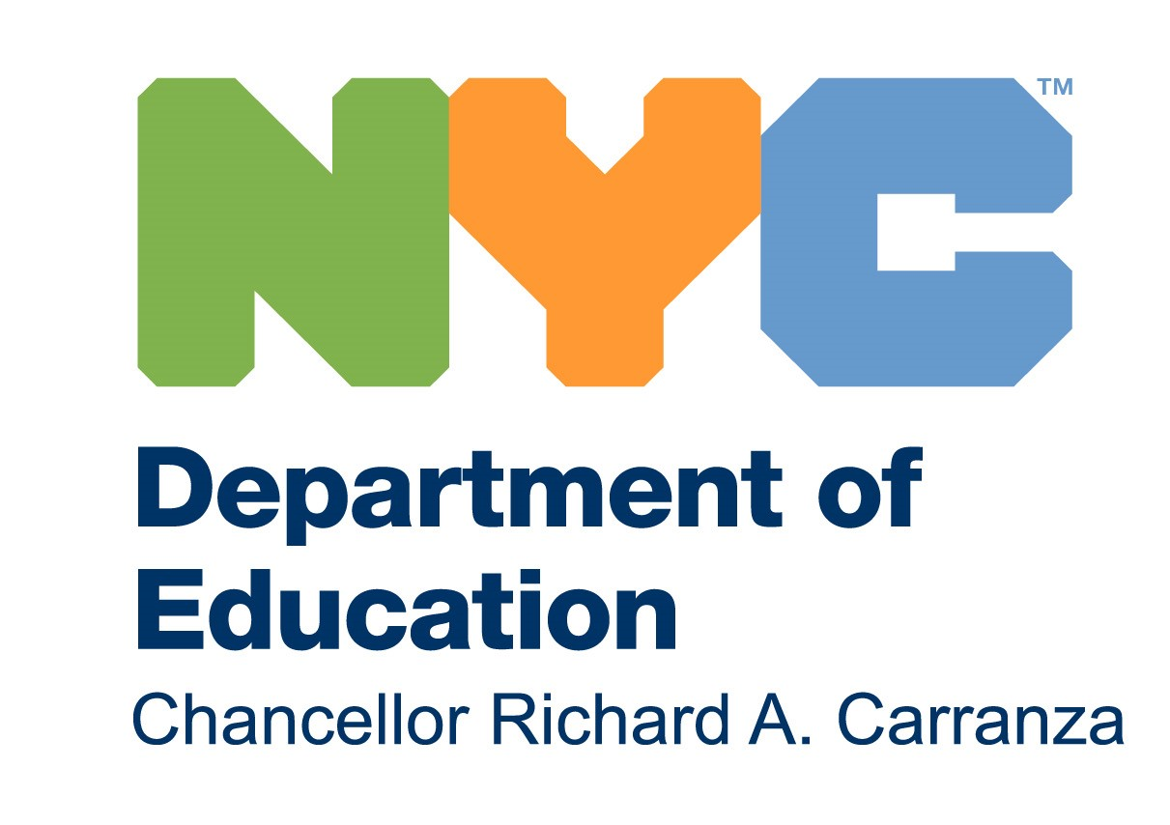

THE NEW YORK CITY DEPARTMENT OF EDUCATION
Anita Skop, Community Superintendent
COMMUNITY SCHOOL DISTRICT 15
131 Livingston Street, Brooklyn, NY 11201
718-935-4317

March 8, 2021

Dear District 15 Community:

I hope that you are safe and healthy, as are all the members of your families. These have been difficult times and hopefully, we will soon be coming to a time of healing both physically and mentally.

Like all times of hardship, stress and fear bring out the best and the worst in us all. This has never been more evident than during this pandemic. It has divided our city in so many ways, not just along socio-economic lines, but politically and culturally, creating atmospheres of distrust and fear. It has also fanned the flames of bias against members of the Asian community who have been targeted in hate crimes as the cause of this modern plague. This week I attended a meeting with educators from across New York State and was moved to tears when a leader in the field, herself an Asian-American woman expressed how she lived in terror every time her daughter took her year-old grandchild out for a walk. Other members of our own staff have shared similar concerns for their own children and grandchildren across the country.

It is heartbreaking that in the twenty-first century, small numbers of people across the city, and across the country have reverted to a medieval response to those whose culture is different and have taken to blaming them for the pandemic. We are a country of immigrants and a lush, gorgeous mix of cultures. It is that very mix that gives our city its strength and makes it a heralded, storied center of commerce, education, art, music, and cuisine. We benefit from each other. Therefore, we must honor and support each other. Our District is a microcosm of our city. We are glorious because of all of our ethnicities and cultures, all of our religions, all of our beliefs, all of our colors. Therefore, it is our responsibility to call out all forms of bias and racism, and to stand with our Asian community in denouncing this evil.

I know that you join me in saying “Enough!” Enough hatred! Enough blame! Enough stereotyping! We are a family and when one member is attacked, we are all diminished. This is what we are striving to teach our children. Let us hope we teach them well and that in their generation it will just be their way of life.

With great hopes for the future,
Anita Skop

