

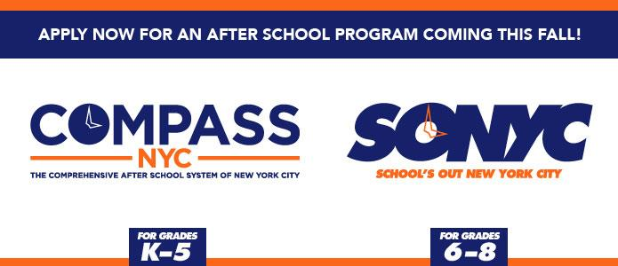

Thursday, October 7th, 2020

Greetings MS 447 Families,

LEAP @ MS 447 Afterschool is pleased to announce that we will begin our In-person Afterschool programming on Tuesday, 10/13.

In-person programming is available for Blended Learning students on their In-person days.

Please be advised that LEAP Afterschool will be adhering closely to the CDC guidelines on COVID prevention. Therefore,  LEAP Afterschool will be operating at a limited capacity. We are only able to serve 50% of our total allotment of participant slots per day and we are only able to offer limited daily activities.

(For the opportunity to participate in a wider range of activities, students are encouraged to enroll into our Virtual program. [To register please click here.](https://ms447brooklyn.us4.list-manage.com/track/click?u=4df2feefb036ec3bedb84523d&id=3125736654&e=7fa86b8f10))

**In-person programming will take place Tuesday-Friday from 2:30-5pm.**

As this is a unique year, LEAP will be offering many activities that will take place outdoors or at local parks. Students who participate in afterschool will always initially meet up inside the school building starting in the cafeteria. Once students are placed in their afterschool packs, they will only meet up in the classroom their pack is assigned to.

In order to participate, students must complete the DYCD Enrollment packet. Additionally, we are asking that parents sign the attached consent form for students to participate in neighborhood walks and/or attend frequent trips to local parks.

Some of those parks include:

South Oxford Park

Fort Greene Park

Prospect Park

MS 51 Outdoor Play Area

On our first day, Tuesday, 10/13, LEAP will be hosting an outdoor Afterschool Kick Off event at South Oxford Park. Students will only be allowed to attend if they have returned the DYCD Enrollment form and Park Visit consent form beforehand, or show up with that documentation on the day of.

The In-person Orientation Packet includes:

LEAP Afterschool Welcome Letter

In-person Afterschool Activity Schedule

Park Consent Form **(Please Return)**

DYCD Enrollment Application **(Please Return)**

***Families that are not comfortable with their child attending In-person Afterschool are encouraged to have their child attend our Virtual program, which takes place Monday-Friday from 3-6pm.

You can apply for the Virtual program via this link: [To register please click here.](https://ms447brooklyn.us4.list-manage.com/track/click?u=4df2feefb036ec3bedb84523d&id=3125736654&e=7fa86b8f10)

Looking forward to an exciting year!

Sincerely,

Tricia



@ MS 447

345 Dean St, RM 314 * Brooklyn, NY 11217* [tricia@leapnyc.org](mailto:tricia@leapnyc.org) * [leap@ms447.org](mailto:leap@ms447.org) * WWW.LEAPNYC.ORG