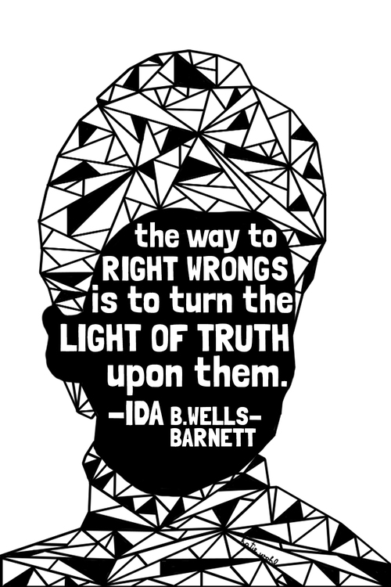

**Grade 7 Exploration Unit 3: Art for Social Change**

|  |
| --- |
| **Unit Description**  Our final unit of 7th grade Exploration is "Art for Social Change." In this unit, we will explore how art can be used to advance positive change in the world by making connections between social activism and artistic practice. We'll explore what art is, who artists are, and think about what justice is. You will reflect on who YOU are both as an artist and an activist.  We'll be seeking inspiration from professional artists and storytellers, and visiting Brooklyn Museum and Socrates Sculpture Park, as well as checking out murals in the neighborhood around our school. For your unit project, you will create a piece of art that speaks to a social issue that matters to you. Possible genres include: dance, visual art, music, spoken word, sculpture, poetry, creative writing… the sky’s the limit! We'll present our art and inspire change at our 7th grade final Expo.  So, start thinking about what kind of change you would like to see in the world, and how you can use your creativity to promote that message! We can't wait to see what you create! |

|  |
| --- |
| **Big Ideas**:   * Art can be a powerful tool to inspire and encourage social change. * Art has been used to influence people and strengthen many social movements throughout history. * Art can be made in many different mediums and people do not always agree on what is art. * We can think about the message of a work of art by describing it, interpreting it, and reflecting/responding to it. * We can advocate for issues we care deeply about by creating art. |

|  |
| --- |
| **Trips:** |
| **ESPO’s Art World and Neighborhood Walk:**  ***Learning Objectives:*** Students will gain exposure to mural work and additional street art. They will be asked to react to the art, identifying feelings that are evoked and messages that are conveyed. Additionally they will meet and hear from artist Stephen Powers at ESPO’s Art World. Stephen will elaborate on his goal of “taking the form of the murals, which are powerful for all the wrong reasons, and trying to retain some of the power and use it in a really good way.” (NY Times Interview) <http://firstandfifteenth.net/outdoor-voice/> |
| **Brooklyn Museum of Art: Nobody Promised You Tomorrow: Art 50 Years After Stonewall**  ***Learning Objectives:***  Students will explore, analyze and strengthen connections between social activism and artistic practice.The exhibition presents twenty-two LGBTQ+ artists born after 1969 whose works grapple with the unique conditions of our political time, and question how moments become monuments. Through painting, sculpture, installation, performance, and video, these artists engage interconnected themes of revolt, commemoration, care, and desire. |
| **Socrates Sculpture Park:**  ***Learning Objectives:*** Students will gain exposure to outdoor sculpture as an art form. They will interact with contemporary public art that works to engage diverse audiences with the five-acre waterfront landscape. Students will use the experience to broaden their understanding of the genres of art and the limitless possibilities of using art to interact with and/or influence the public. |

|  |
| --- |
| **Visiting Artists:** |
| **Art Activist Rachel Shagris:** Rachel is a visual artist, cultural organizer, and lifelong New Yorker. She began her organizing work with Occupy Wall Street and the Domestic Worker Justice movement, was the arts coordinator for the People’s Climate March, and is currently the co-coordinator of arts engagement for Flood the System. She is a founding member of the People’s Climate Arts collective, where she continues to organize with artists to use cultural strategies to fight for climate, racial and economic justice in NYC and beyond. |
| **Storyteller April Armstrong:** April weaves melodies and words for a refreshing and compelling style of storytelling. Her story programs are fun and interactive. She tells multicultural tales, including African-American and Latino stories. April's stories delight, inform and inspire audiences of all ages. |

|  |
| --- |
| **Projects:**  **Individual or Team Project:** Create a piece of art that speaks to a social issue that matters to you! Possible genres include: dance, visual art, music, spoken word, sculpture, poetry, creative writing… the sky’s the limit!  Present your art and inspire change at our 7th grade final Expo.  **Individual Project:** Artist’s Notebook |