MS 447 Exploration
7th grade C Day Unit 2 EXPO

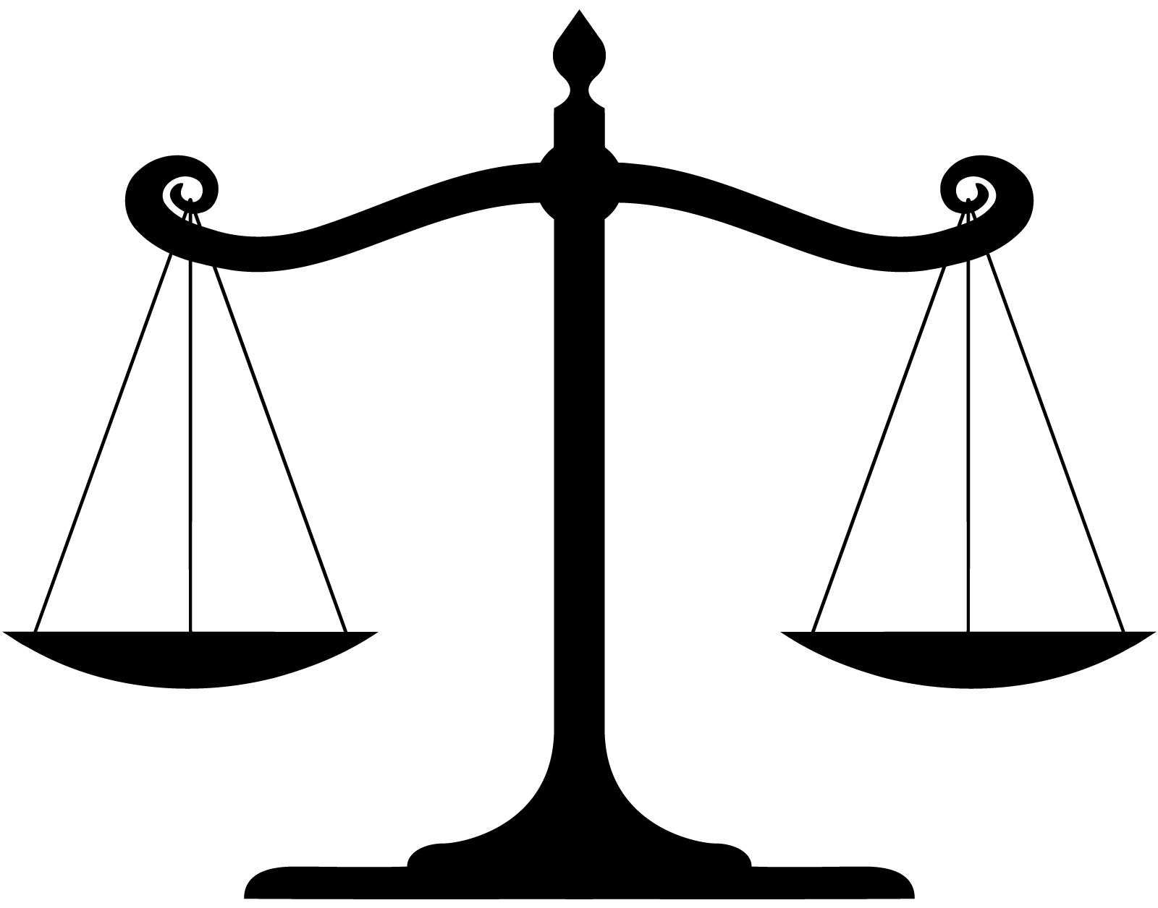
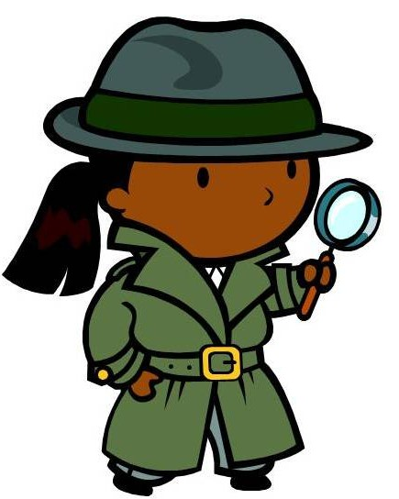

Forensics and Justice

- Learn more about forensic science and the criminal justice system through our individual research projects

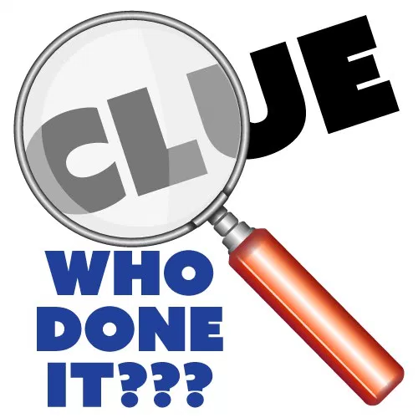
- Evaluate our evidence boards -- decide for yourself
Please join us in rooms
324, 326, and 327

12:30 - 1:30 PM
BLUE RED YELLOW: Thursday April 11

