

**Black Lives Matter**

Week of Action in Schools

February 4-8, 2019

**Celebrate BLM @ MS 447 with the following activities:**

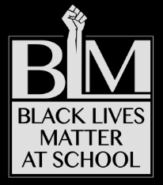

**Monday 2/4**

**BLM T-Shirt Day**

Wear any BLM or black colored T-shirt

**Photo Booth**

Hang your picture in solidarity and support of BLM at School

**Tuesday 2/5** No School

**Wednesday 2/6**

**#BlackLivesMatterAtSchool**

Join the bulletin board dialogue

**Thursday 2/7**

**BLM Button Day**

**Imagine:**

A Creative Community Night @ 6pm

**Friday 2/8**

**BLM Mural Day**

Co-create in solidarity and support

**Endorse**

2019 National Black Lives Matter at School Week of Action at change.org