MS 447 Exploration
7th grade Unit 1 EXPO



Engineering and REsponsible Urban Design

- check out Various Engineering Strategies in our skyscrapers
- Hear what we learned about REsponsible Urban Design
- Investigate our case studies about nyc sites
Please join us in Rooms
324, 326, and 327

10:00 - 11:15 Am
BLUE RED YELLOW: Monday December 17
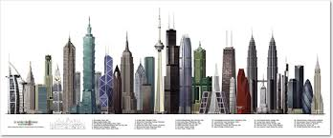
GREEN ORANGE PURPLE: Tuesday December 18

