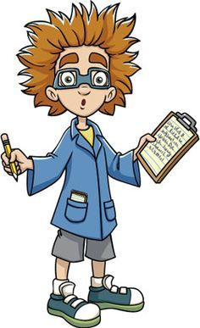
MS 447 Exploration
8th grade Unit 1 EXPO
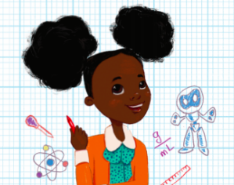
Inventions for a
Better World

Curious about how to design, invent and innovate for a better tomorrow ???
check out our ideas as we showcase our
- Invention and innovation Schematics
- tEam Design Challenges
Please join us in Rooms
324, 326, and 327

11:30 am - 1:oo pm

BLUE RED YELLOW: Wednesday December 5
GREEN ORANGE PURPLE: Thursday December 6

