

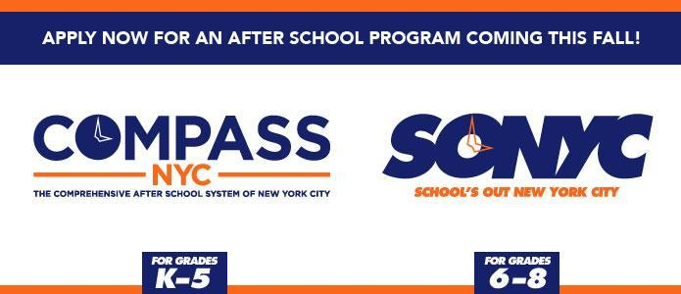

LeAp @ MS 447 SPRING BREAK FIELDTRIP CONSENT FORM

Dear LeAp @ MS 447 Parents,

LeAp will be open for activities for 3 days on Monday 4/2, Tuesday 4/3, and Wednesday 4/4 during the Spring Break! LeAp participants will attend fieldtrips on all 3 days. Please see the details below for more information. Students should arrive to MS 447K no later than 9:45am. All students will meet and gather at the main entrance of MS 447K on Dean St. The LeAp program will depart for all trips by 10am. LeAp will travel, free of charge via subway. . LeAp will provide a light snack throughout the day, but it is advised that all students also bring in a lunch from home. Students will return to MS 447K by 3pm. Students should arrive with this form filled out on the day of the trip. *Please be advised any student wishing to attend must complete the LeAp enrollment form, if they have not already done so.* For any questions contact Ms. Tricia Frazier via email at [tricia@leapnyc.org](mailto:tricia@leapnyc.org) or [leap@ms447.org](mailto:leap@ms447.org) or call at (212)769-4160 x152. Thank you.

CHILD’S NAME:__________________________________________ DATE OF BIRTH:________________________

|  |  |  |  |
| --- | --- | --- | --- |
| **Date of Trip** | **Mode of Transportation** | **Destination** | **Estimated Arrival Time** |
| Monday, April 2nd, 2018 | Subway | **AMERICAN MUSEUM OF NATURAL HISTORY**  [Central Park West @ 79](http://nycbasketball.leagueapps.com/location/19733)[th](http://nycbasketball.leagueapps.com/location/19733) [ST](http://nycbasketball.leagueapps.com/location/19733)  [New York, NY 10024](http://nycbasketball.leagueapps.com/location/19733) | Leave MS 447k: **10am**  Arrive @ MS 447k: **3pm** |
| Tuesday, April 3rd, 2018 | Subway | **NEW YORK AQUARIUM**  [602 Surf Ave](http://nycbasketball.leagueapps.com/location/19733)  [Brooklyn, NY 11224](http://nycbasketball.leagueapps.com/location/19733) | Leave MS 447k: **10am**  Arrive @ MS 447k: **3pm** |
| Wednesday, April 4th t, 2018 | Subway | **AMC LOEWS 34TH ST**  *A WRINKLE IN TIME*  [312 W. 34](http://nycbasketball.leagueapps.com/location/19733)[TH](http://nycbasketball.leagueapps.com/location/19733) [St](http://nycbasketball.leagueapps.com/location/19733)  [New York, NY 1oo1](http://nycbasketball.leagueapps.com/location/19733) | Leave MS 447k: **10am**  Arrive @ MS 447k: **3pm** |
| ***PLEASE BE ADVISED IN ORDER FOR STUDENTS TO ATTEND THIS TRIP, THEY MUST HAVE ATTENDED AT LEAST 1 OF THE PREVIOUS TRIPS*** | | | |

PARENT PRINT NAME: _____________________ PARENT SIGNATURE:________________ PHONE #:_____________ DATE:___________