**PERCEPTION EXPO**

During the Perception Expo 8th Grade Students will present their Cause Campaigns in an effort to counter negative cultural stereotypes and generalizations presented by the media.

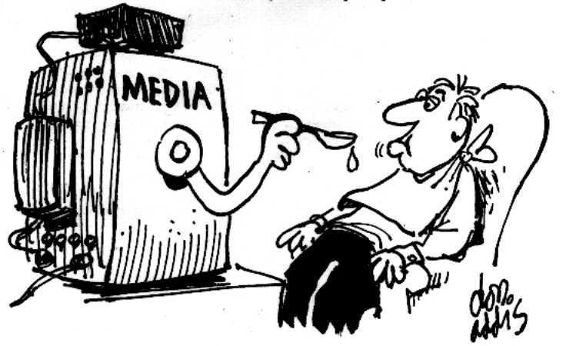

**Blue/ Red/ Yellow   A Day                      March 17th**

**Green/ Orange/ Purple   B Day              March 20th**

**11:30 A.M. - 1 P.M.**

**Room 324, 326 and 327**