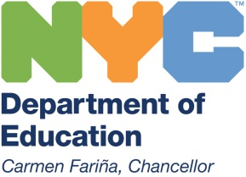 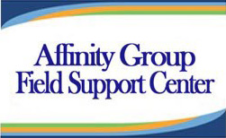 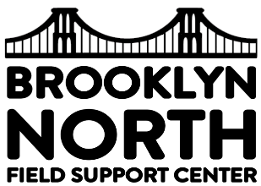

**Brooklyn North Family Night**

**“Building Connections and Empowering Families”**



**Hosted by Brooklyn North and Affinity FSC**

**October 25, 2016**

**4:30pm – 7:30pm**

**Adams Street Educational Campus**

**283 Adams Street**

**Brooklyn, NY 11201**

* **A Variety of Parent Workshops**
* **Learn more about Special Education & English Language Learners**
* **Parent Information and Resources**
* **Make Connections with Organizations and Educators**
* **Ask Questions**
* **Win a Door Prize & more…**

**\*RSVP with your School Parent Coordinator**

**For more information: Zoe Lence Calix:** [**Zlencecalix@schools.nyc.gov**](mailto:Zlencecalix@schools.nyc.gov)