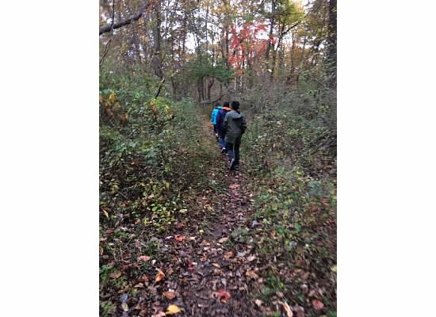

Camp Bernie Packing List

Oct. 19th - Oct. 21st

In order for students to be safe and comfortable while at Camp Bernie, it is important that they come prepared!

|  |
| --- |
| Required Items:  *\*\*All belongings should be labeled with the student’s name.* |

□ Weather appropriate outdoor clothing (layers are highly recommended)

* Enough for three days worth of cold/wet weather & mild weather (if we are lucky!)
* Gloves

□Fleece, hoodie, (maybe a knit hat for the night hike) ***AND*** a comfortable jacket

□Undergarments, pajamas

□Socks and shoes (sneakers or boots only - shoes designed for outdoor activity)

□Rain gear

□Sleeping bag or bedding for one twin bed - including pillow, sheets, and blanket

□Toiletry bag with necessary items - toothbrush, paste, soap, deodorant, towel, flip flops for shower, etc...

|  |
| --- |
| What NOT to Bring: |

□All jewelry

□Expensive belongings (electronics devices such as reading tablets, IPods, IPads)

□Anything with sentimental value should be left at home

|  |
| --- |
| Cell Phones: |

□Cell phones **usage** during Camp Bernie activities are prohibited, however students may call

home in the evenings. If a student feels the need to call home at any point of the day, they may do

so with the support of a MS 447 staff member.

□Should a student bring a cell phone, it must remain turned OFF and in the student’s BUNK AREA.

We will continue to update you with information pertaining to the trip. Camp Bernie is also discussed in your child’s advisory group. Their advisor is a good point person for questions or in general as the year progresses.