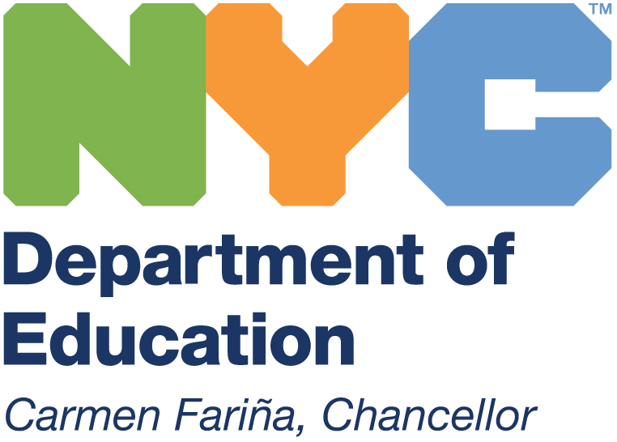
THE NEW YORK CITY DEPARTMENT OF EDUCATION
Anita Skop, Community Superintendent
COMMUNITY SCHOOL DISTRICT 15
131 Livingston Street, Brooklyn, NY 11201
718-935-4317

May 11, 2016
Dear District 15 Colleagues and Families:
In partnership with the Community Education Council, district middle and elementary school principals, and the greater District 15 community, I am pleased to announce that we are making positive steps toward a more inclusive, equitable and family-friendly middle school admissions process for all of the District 15 community. This will begin with the application process during the 2016-2017 school year and will impact students who are in 5th grade next year.
Beginning with admissions for students entering 6th grade in September 2017, District 15 will have an admissions process where the middle schools do not have access to and do not use information about where an applicant ranked the middle school on the application.
For many years, middle schools have had access to how families rank them as a part of the admissions process. This knowledge has brought unnecessary stress for families in the admissions process and has left families feeling as though their choices were limited in the application process. For years, families have felt as though their options were limited to two top schools on their applications and have felt as though they need to be strategic, rather than honest in their ranking of choices. As a result, families have limited their top choices to just a few schools.
Based on community feedback and the support of the middle school principals in the district, we are making this change to support District 15 families. I want to commend the middle school principals for embracing a change that greatly benefits families and also creates more equity among our middle schools. Families can now express their true preference when applying to middle school without fear of not being considered because of how they ranked a particular middle school on the application.
In addition, we have also eliminated the use of letters of recommendation as part of the application process. Schools have been instructed that such letters are not to be requested or weighed if they are submitted. It is my hope that these important changes will lead to a more robust application process, and ultimately, to greater access for all of our families to the great wide range of excellent middle school choices in our district.
Questions about these improvements or the middle school admissions process can be directed to your school’s Parent Coordinator, Guidance Counselor or to the Office of Student Enrollment at 718-935-2398.
Warmest regards and best wishes,
Anita Skop
Superintendent, Community School District 15

