December 5, 2014

Dear MS 447 Families,

We have an exciting (and last minute!) opportunity to share with you. December 8th kicks off Hour of Code, an international campaign to introduce computer science and coding to young people. Over the course of the week, all MS 447 students will participate in coding activities in their tech class, in which they will work through a tutorial and learn to write basic computer programs.

In addition to these activities, on Monday, December 8, we will have a special visit from NBA legend and global ambassador Dikembe Mutombo, in partnership with Code.org and NBA Cares. He will work with a small group of students who participate in our SONYC after school tech programs, and will also make a brief presentation and Q&A, open to any students who are interested in attending. If your child would be interested in attending Mutombo’s presentation, please read the following information carefully, as all participating students must have three releases signed by a guardian.

Motumbo will present at 4:00 p.m. in the gym on December 8. Students who are not enrolled in after school may stay at school until the event, with supervision in the gym. Those enrolled in after school will participate in their regular after school activities until then. **Only students with signed releases from the NYC Department of Education, NBA Cares, and Code.org will be permitted to stay.** Students will be dismissed at approximately 4:30, through the main entrance at 345 Dean Street. The releases are attached to this letter, and are also posted on our website (ms447.org).

We hope your child chooses to participate on Monday. We are excited about the opportunity to highlight both our in-school technology programs for all of our students, as well as enrichment opportunities in technology education for after school students.

Please contact Amy Sirot, Parent Coordinator, if you have any questions.

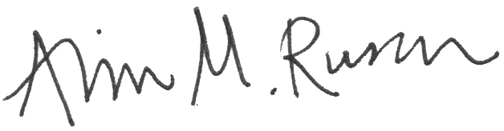Sincerely,

Arin Rusch

Principal IA