

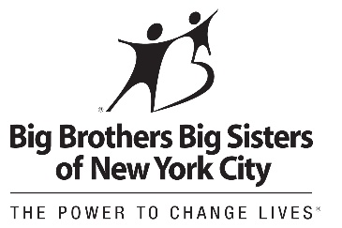

Dear MS 447 Parent/ Guardian,

We hope that your child had a wonderful summer and is looking forward to a new school year with MS 447. With the school year close upon us, we want to introduce a new program that is being piloted as part of Mayor DeBlasio’s new initiative for middle school students- School’s Out NYC! This program is being facilitated by Big Brothers Big Sisters of NYC at MS 447 on a daily basis on Mondays to Thursdays from 2:20- 5:45 pm and Fridays from 2:20-5:15 pm. This is a great opportunity for kids to take advantage of fun after school activities!

This program is FREE! Space is limited. Students must submit enrollment forms to register. Enrollment forms will be available on the first day of school for students to take home to be completed by parent/ guardian.

Questions? Feel free to contact me at 646-647-5862.

We look forward to seeing your child at our new School’s Out NYC program in September!

Sincerely,

Antonio Capellan

Program Director

School’s Out NYC at MS 447