7th GRADE REWARD TRIP PERMISSION FORM: PLEASE COMPLETE AND HAVE YOUR CHILD RETURN
IT TO THEIR MATH TEACHERS NO LATER THAN MONDAY, DECEMBER 4TH.

NYC PARENT NOTIFICATION/CONSENT FORM DAY TRIP Chancellor’s Regulation A-670
Trip Date: Wednesday, December 20th
Trip Coordinator: Chrissy Vissa/Cara Haft
Purpose of Trip: Fostering school community and celebrating the successful completion of the first trimester of 7th grade!

Student Name: ________________________________________Class: _____________

Circle your first choice:

OPTION A: NY HALL OF SCIENCE (QUEENS)  Includes entrance to special interactive exhibit: Connected Worlds (see back for more info)  Mode of Transportation: Yellow Bus  COST: $10.00 (Lunch is not included. Pack a bagged lunch or indicate below if you’re requesting a school lunch.) | OPTION B: MOVIE SCREENING TBA, Cobble Hill Cinemas  (see back for more info)  Mode of Transportation: Walking  COST: $10.00 (lunch is not included)  Optional: Kids’ snack combo $6.00
Departure Site/Time: MS 447, 345 Dean Street: 9:30 AM  Return Site/Time: MS 447, 345 Dean Street 1:30 PM  - Lunch will be eaten in the NY Hall of Science Cafeteria before we return to school | Departure Site/Time: MS 447, 345 Dean Street: 9:30 AM  Return Site/Time: MS 447, 345 Dean Street 1:00 PM  - Lunch will be eaten in the MS 447 Cafeteria

a) I understand that there are risks of injury associated with the above-listed physical and sports activities and I consent to my child’s participation in all these activities except for the following:
_________________________________________________________________________________________________
b) Please indicate below any permanent or temporary medical or other condition, including special dietary and medication needs, or the need for visual or auditory aids, which should be known about your child:
_________________________________________________________________________________________________
c) I agree that in the event of an emergency injury or illness, the staff member(s) in charge of the trip may act on my behalf and at my expense in obtaining medical treatment for my child.
d) I understand that my child is expected to behave responsibly and to follow the school’s discipline code and policies.
e) I agree and understand that I am responsible for the actions of my child. I release the school from all claims and liability that arise in connection with the trip, except if due to the negligence of school officials.
f) I understand that I am responsible for getting my child to and from the departure and return sites identified above. I understand that my child shall be accompanied by staff member(s) during the trip, including while traveling from the departure site to the destination site, and from the destination site to the return site.
g) I understand that alcoholic beverages and/or illegal drugs are prohibited and have discussed this prohibition with my child. I understand that if my child is found in possession of these substances, he/she will be subject to school disciplinary procedures and possible criminal prosecution.
h) I understand that students who violates the school's discipline code may be excluded in the future by the school from participating in a trip.
i) In an emergency I can be reached at:
Day: (___) ____________________________ Evening: (___)_____________________________
Additional Contact: Name: _________________________________________________________
Day: (___) _____________________ Evening: (___) ____________________________________
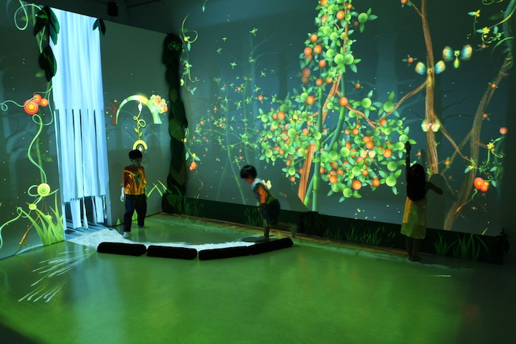

OPTION A: Connected Worlds Interactive Science Exhibit—
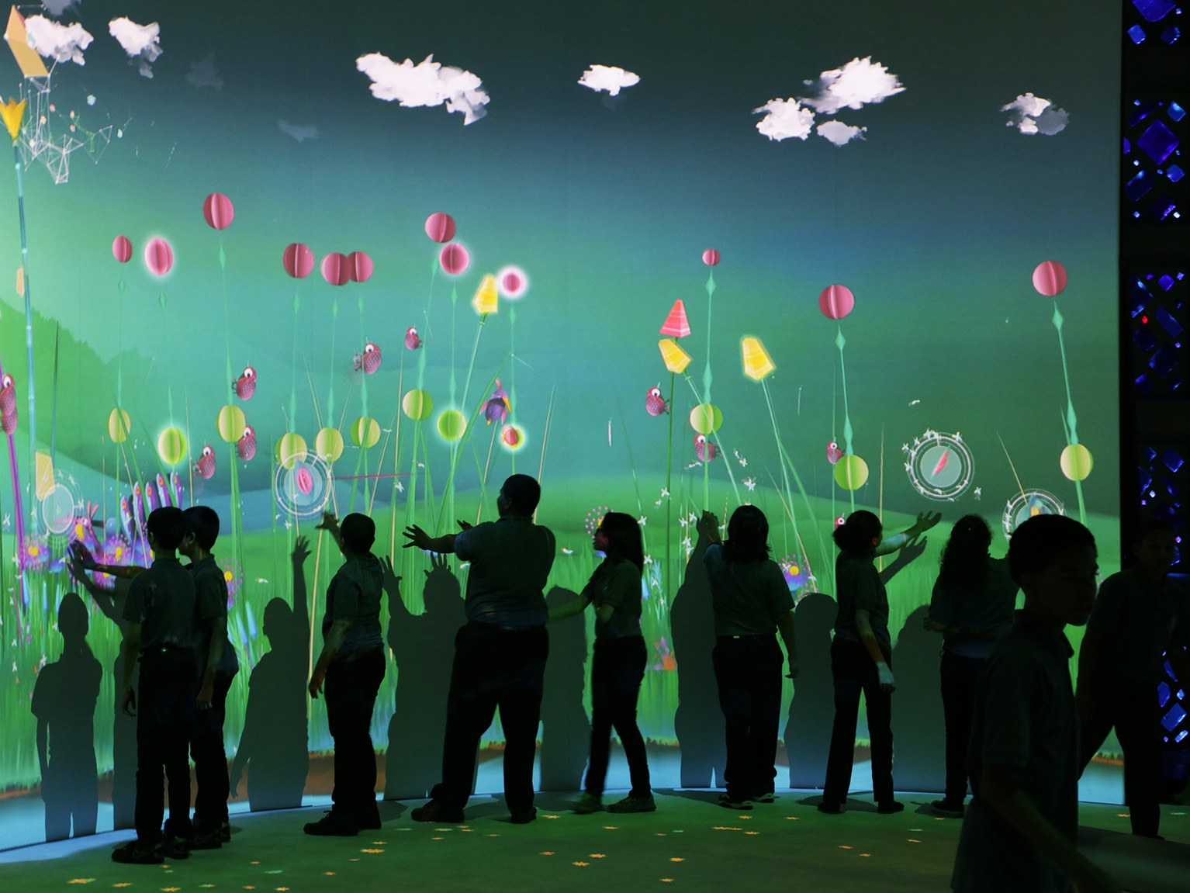
Read what Time Out NY has to say about it:
With so many people bustling around NYC at all times, it's easy to forget that our city is just a small piece in a larger environment. This high-tech exhibition in the Great Hall lets us better understand our impact on Earth's delicate systems, teaching kids how to keep things balanced through individual and collective actions. Visitors interact with animated creatures, plants, trees and other objects on seven giant screens. Each displays a different environment —desert, mountain valley, plains, reservoir, jungle wetlands and a digital waterfall, towering above at 38 feet tall. As visitors move from one environment to the next they'll explore how the spaces are connected by shared resources and weather patterns and how actions like creating dams, growing plants, and cutting trees impact the larger environment.
____(check here) I give my permission for my child to participate in this school trip to the NY Hall of Science
____(check here) I am including $10.00 (exact change, please!)
____(check here) I request a school lunch for my child

OPTION B: Movie Screening at Cobble Hill Cinemas—
First-run, rated PG films that may be available for our date include: Wonder, Coco, Ferdinand, and The Greatest Showman (the P.T. Barnum story). We won’t know our choices until the week prior!

Optional Snack Combo for $6.00 includes water, kids’ size popcorn, fruit snacks

____(check here) I give my permission for my child to participate in this school trip to Cobble Hill Cinemas ____(check here) I am including $10.00 (exact change, please!)
Or ____(check here) I am including $16.00 for a movie ticket and snack combo (exact change, please!)

__________________________________________________________________________________________________
____(check here) I am also including a donation of $ ____ to help pay for students in need.
____(check here) I do not give my child permission to participate in this school trip.
______________________________________________________________________________
(Signature of Parent/Guardian) (Date)
STUDENT DECLARATION (to be signed by Middle School and High School students) I have read this form and I understand that I am to act on this trip in the same responsible manner in which I am expected to conduct myself in school._________________________________________________________________________
(Signature of Student) (Date)

