

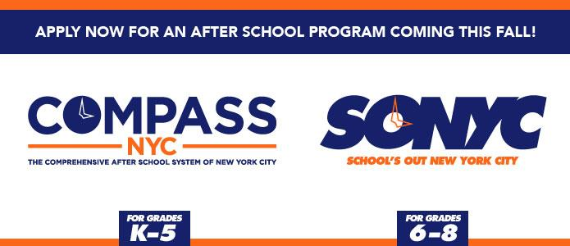

Monday, November 13th, 2017

Dear MS 447 Parents,

LeAp is extremely excited to be hosting this free yearlong Afterschool Program here at MS 447. The program will run Monday-Friday from 2:35pm-5:35pm, with dismissal starting at 5:20pm. FRIDAY DISMISSAL IS @ 5PM. The program dates are November 13th-June 22nd. Snacks are served daily. Attendance is taken daily, so it is important that your child shows up consistently. As an Afterschool participant, your child can take advantage of the wide range of both recreational and enrichment activities that we have to offer. Those activities include: Theater, Dance, Social Action, Robotics, Photography, Visual Arts, Music, Basketball, Football, Soccer, and various club choices.

**Please be advised:** Students who already attending MS 447 Afterschool activities such as: Musical Theatre, Basketball, Student Council, Wrestling, Newspaper and Yearbook will be required to enroll into LeAp Afterschool. As a LeAp participant those students will receive a daily snack and are eligible to participate in the wide range of activities offered by LeAp 5 days a week.

**FOR THE 1ST WEEK ONLY, THURSDAY, 11/16 AND FRIDAY, 11/17, ONLY MS 447 AFTERSCHOOL ACTIVITIES WILL OPERATE, (MUSICALTHEATRE/BASKETBALL/ WRESTLING/ NEWSPAPER/YEARBOOK). THERE WILL BE NO LeAp AFTERSCHOOL.**

**REGULAR LeAp PROGRAMMING WILL COMMENCE, MONDAY, 11/20.**

Spots are still available! LeAp would like to invite you to a Parent Informational Session on **Friday, December 1ST, 2017 @ 5pm**. I hope to see you there. We are looking forward to a great year!

Sincerely,

__________________

Tricia Frazier – Program Director



@ MS 447

345 Dean St, RM 314 * Brooklyn, NY 11217* [tricia@leapnyc.org](mailto:tricia@leapnyc.org) * [leap@ms447.org](mailto:leap@ms447.org) * WWW.LEAPNYC.ORG