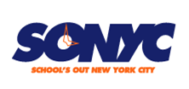
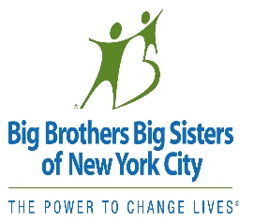
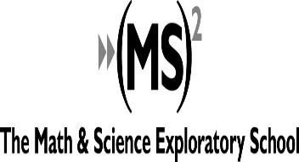
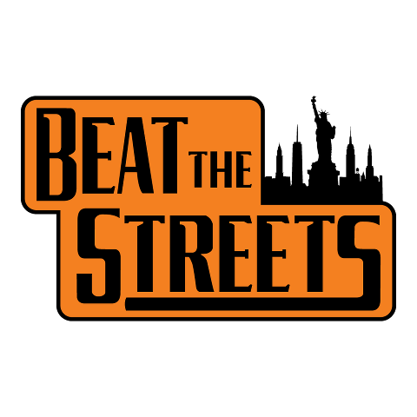

Dear Parents,

We are excited that MS 447, in partnership with Big Brothers Big Sisters of NYC’s SONYC After school program will be offering a Beat the Streets Junior League Wrestling program this fall. The program is FREE and is open to any girl or boy in grades 6th – 8th grade.

Wrestling is a GREAT sport, and it’s for EVERYBODY – girls and boys, big and small, tall and short. The sport improves fitness, helps build self-confidence, and develops the traits of resiliency and commitment in those who participate.

SONYC @ MS 447 is excited to be a Beat the Street (BTS) partner. BTS is a New York City non-profit with the mission “to develop the full human and athletic potential of the urban youth and to strengthen the culture of New York City Wrestling.”

Our team will practice from 2:45 – 4:15pm on Wednesdays and on Thursdays. The season starts on September 16th and runs through November 17th. All participants, novice to advanced, will have the opportunity to compete against others of a similar skill level and size at Beat The Streets Saturday Jamborees in October and November.

As noted in the BTS mission statement Beat The Streets is more than just wrestling, and our Wrestler’s Mark Character Development program is an integral part of our season. The goal of our Wrestler’s Mark program is to highlight the positive personal character and life skill attributes that our sport helps young people develop and to acknowledge and celebrate our student-athletes as they adopt and incorporate these personal character traits from the mat to their lives.

In order to participate a student simply needs to complete the Parent Authorization and Waiver Form (attached) and return it to Coach Grau (Room 327) as soon as possible.

If you have any questions please contact Coach Grau at Grau447math@gmail.com

We are looking forward to having your child be a part of our program!

Sincerely,
Coach Grau, MS 447 Wrestling/ SONYC Activity Specialist

